**WEEK 1:**

* Regression analysis or Regression model: a group of statistical techniques that use existing data to estimate the relationships between **a single dependent** variable and **one or more independent** variables.

(Phân tích hồi quy hoặc Mô hình hồi quy: một nhóm các kỹ thuật thống kê sử dụng dữ liệu hiện có để **ước lượng mối quan hệ** giữa **một biến phụ thuộc duy nhất** và **một hoặc nhiều biến độc lập**.)

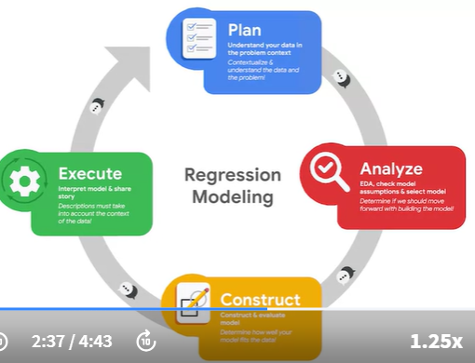

* Model assumptions: statements about the data that must be true to justify the use of particular data science techniques.

**Introduction to Linear regression**

* Line: a collection of an infinite number of points extending in 2 opposite directions

(Đường thẳng: một tập hợp vô số điểm kéo dài theo hai hướng đối diện.)

* Linear regression: a technique that estimates the linear relationship between a **continuous** dependent variable and one or more independent variables.

(Hồi quy tuyến tính: một kỹ thuật ước lượng mối quan hệ tuyến tính giữa một **biến phụ thuộc liên tục** và một hoặc nhiều biến độc lập.)

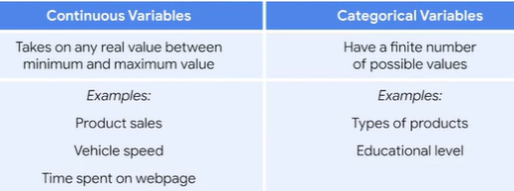

* Dependent variable (Y): the variable a given model estimates, also referred to as a response or outcome variable.
* Independent variable (X): a variable that explains trends in the dependent variable, also referred to as an explanatory or predictor variable.

(• Biến phụ thuộc (Y): là biến mà mô hình ước lượng, còn được gọi là **biến phản hồi** hoặc biến kết quả.

• Biến độc lập (X): là biến giải thích các xu hướng trong biến phụ thuộc, còn được gọi là biến giải thích hoặc biến dự báo.)



* Slope: the amount that y increases or decreases per one-unit increase of x

(Độ dốc: lượng mà y tăng hoặc giảm khi x tăng một đơn vị.)

* Intercept: the value of y, the dependent variable, when x, the independent variable, equals 0.

(Giá trị cắt trục: giá trị của y, biến phụ thuộc, khi x, biến độc lập, bằng 0.)

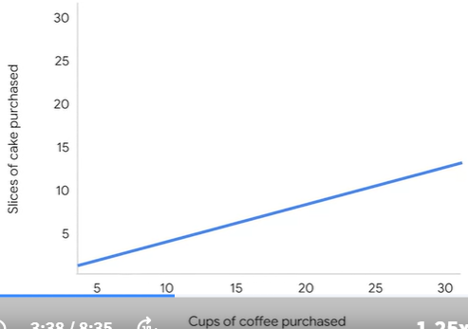

* Positive correlation: a relationship between 2 variables that tend to increase or decrease together

Ex: more cups of coffee purchased🡪 more cakes are purchased

(Mối quan hệ tương quan dương: mối quan hệ giữa hai biến có xu hướng tăng hoặc giảm cùng nhau.)

* Negative correlation: an **inverse relationship** between 2 variables, where when one variable increases, the other variable tend to decrease, and vice versa.

(Mối quan hệ tương quan âm: mối quan hệ ngược chiều giữa hai biến, khi một biến tăng thì biến kia có xu hướng giảm và ngược lại.)

**<!!!>** Correlation IS NOT causation

* Causation: a **cause-and-effect relationship** where one variable directly causes the other to change in a particular way

(Quan hệ nhân quả: mối quan hệ nguyên nhân và kết quả, trong đó một biến trực tiếp gây ra sự thay đổi của biến kia theo một cách cụ thể.)

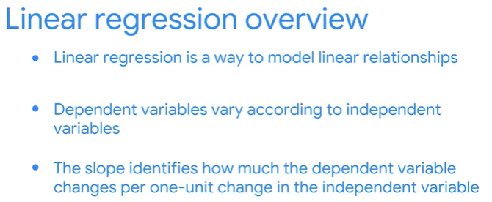

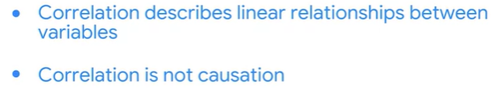

**Mathematical Linear Regression**

* Observed values (actual values): the existing sample of data

Each data point is the sample is represented by an observed value of the dependent variable and an observed value of the independent variable.

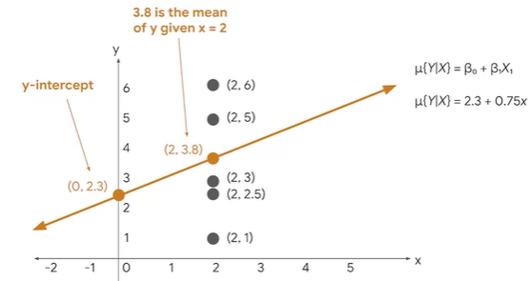



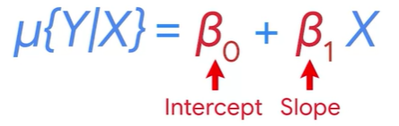

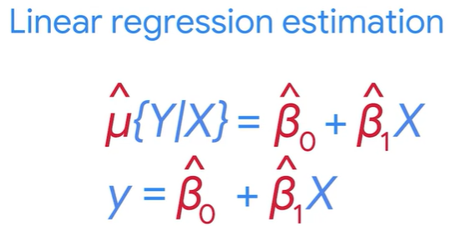

* Regression coefficients: the estimated betas in a regression model. Represented as β^i
* Ordinary Least Squares Estimation (OLS): common way to calculate linear regression coefficients 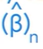
* Loss function: a function that measures the distance between the observed values and the model’s estimated values.

**Introduction to logistic regression**

* Logistic regression: a technique that models a categorical dependent variable based on one or more independent variables

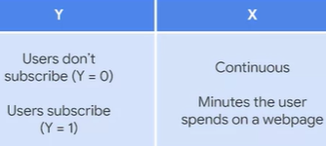

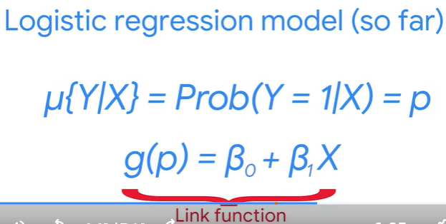

* Link function: a nonlinear function that connects or links the dependent variable to the independent variables mathematically.

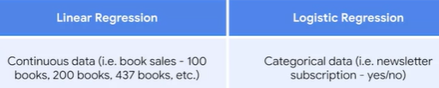

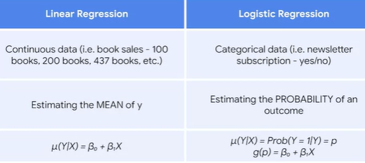

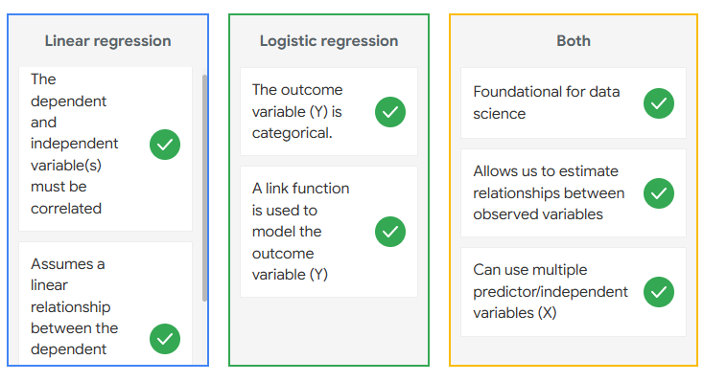

**WEEK 2:**

* Best fit lines: the line that fits the data best by minimizing some loss function or error.
* Predicted values: the estimated Y values for each X calculated by a model.
* Residual: the difference between observed or actual values and the predicted values of the regression line



<!!!> the sum of the residuals is always equal to 0 for OLS estimators

* Sum of squared residuals (SSR): the sum of the squared differences between each observed value and its associated predicted value.

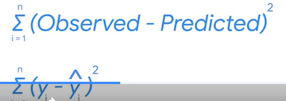

* Ordinary Least Squares (OLS): a method that minimizes the sum of squared residuals to estimate parameters in a linear regression model.

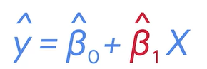

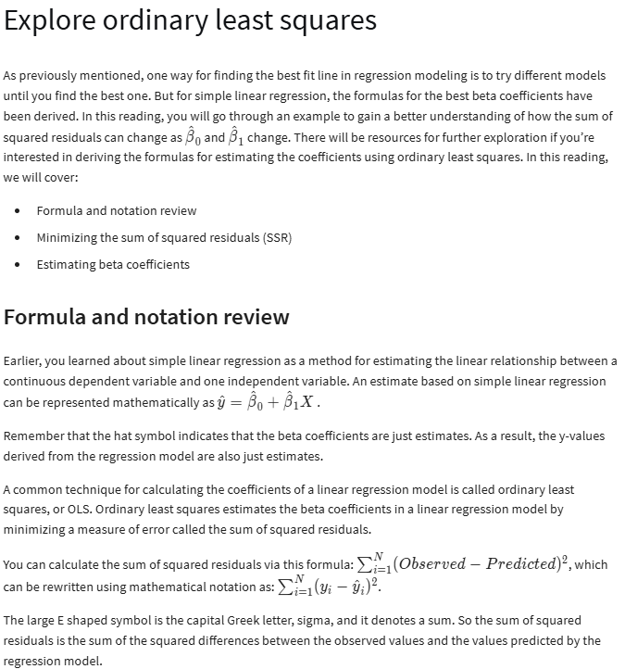

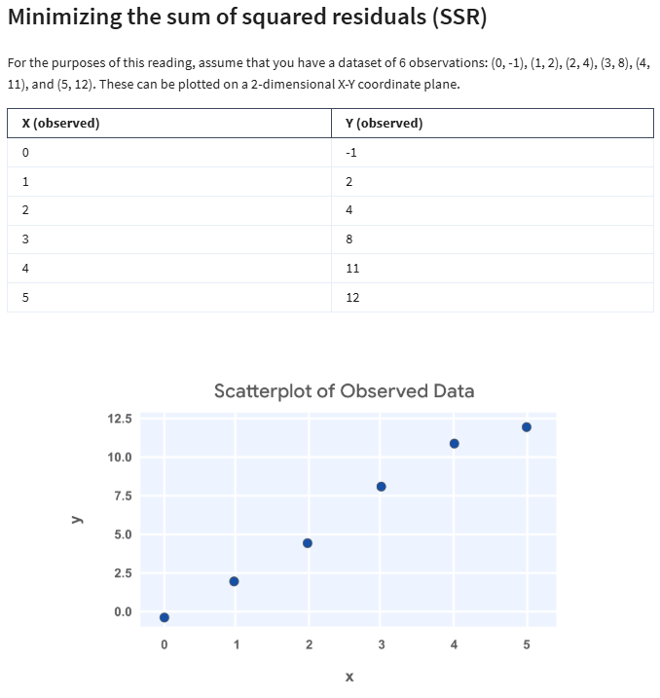

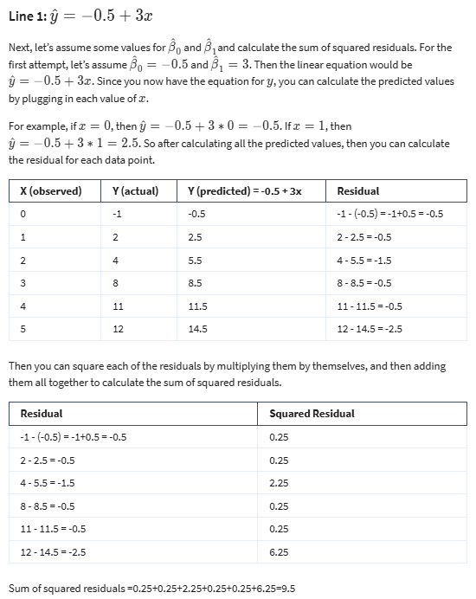

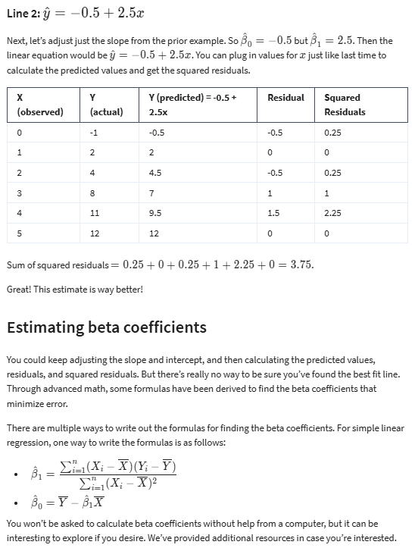

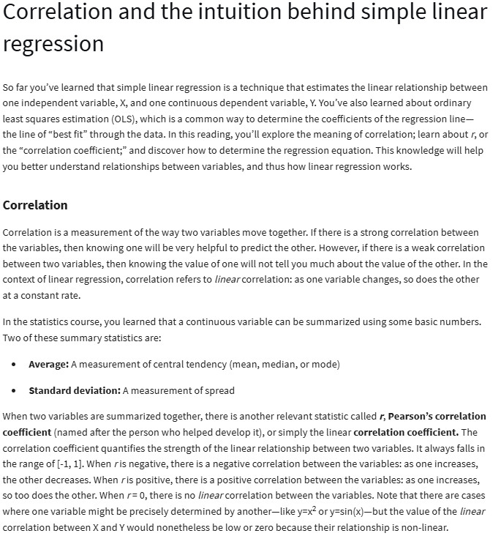

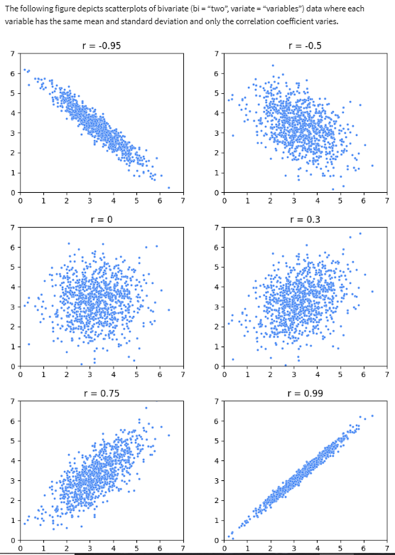

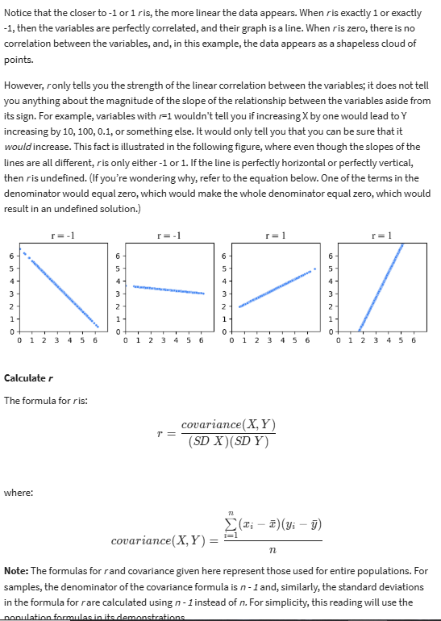

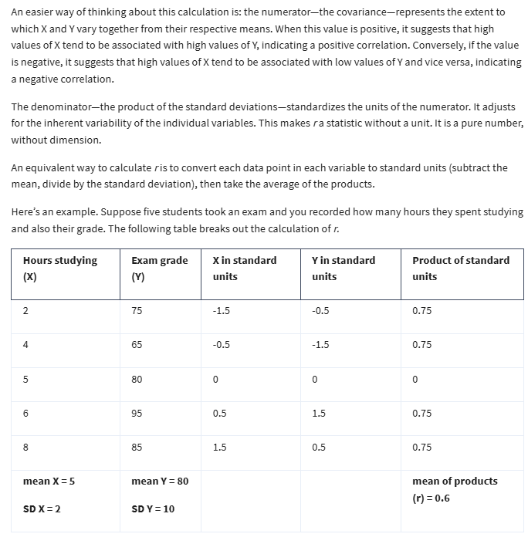

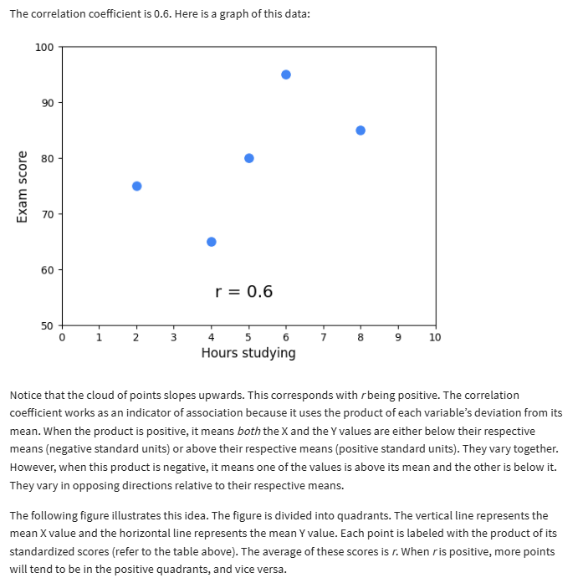

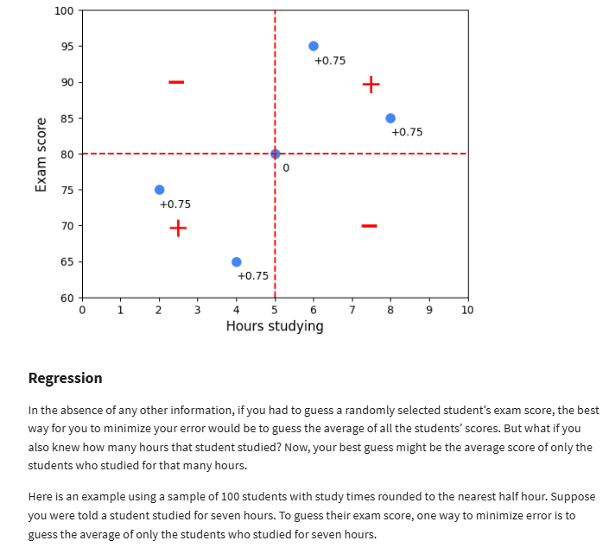

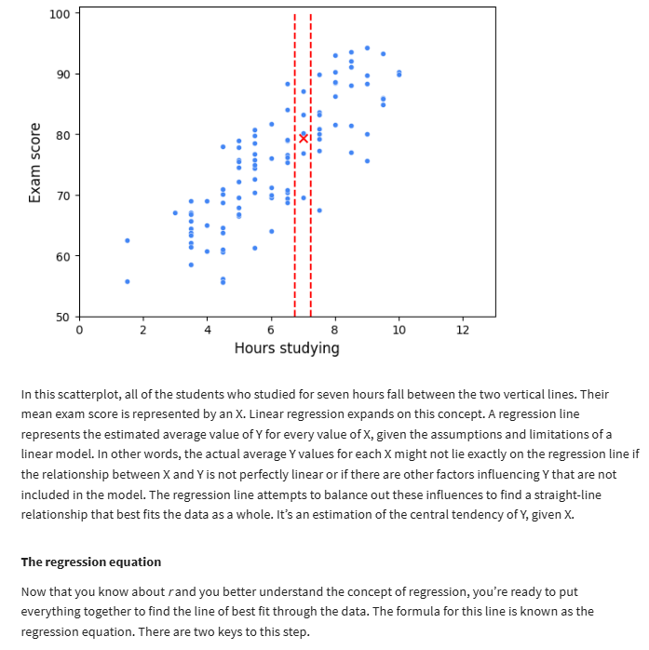

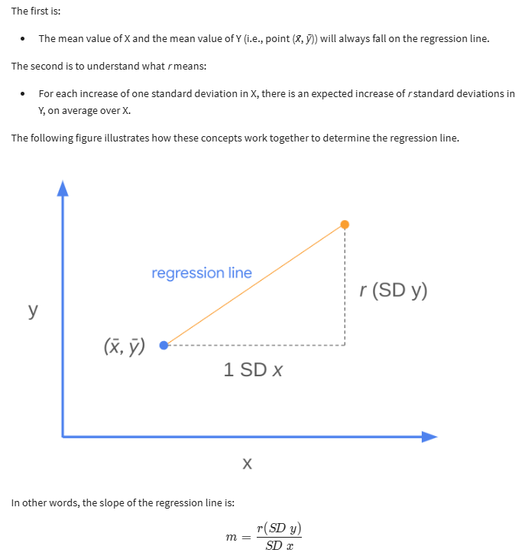

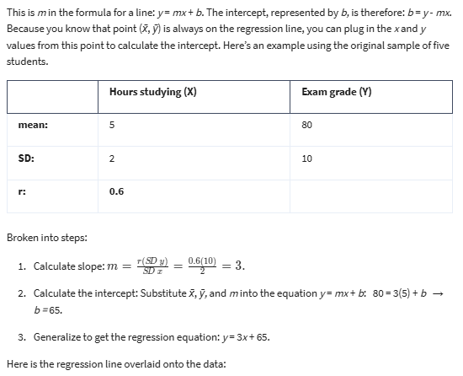

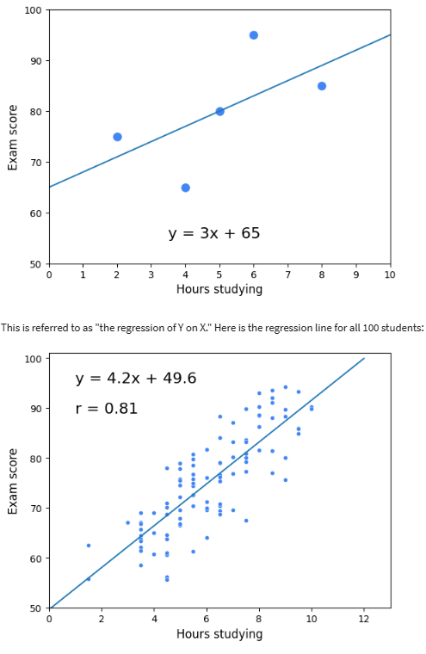

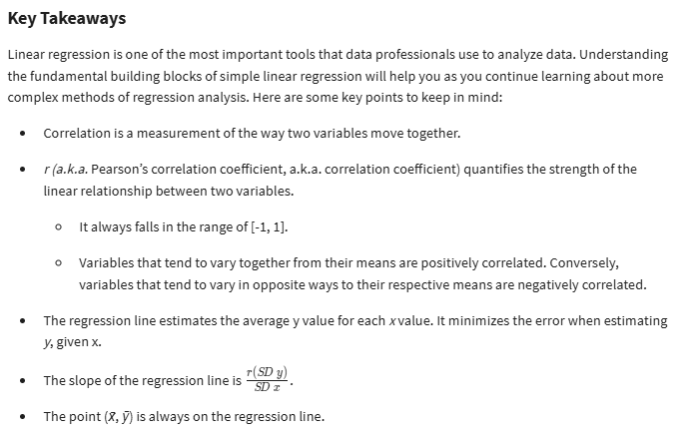

**Make linear regression assumptions**

* Linearity
* Normality
* Independent observations
* Homoscedasticity
* Linearity assumption: each predictor variable (Xi) is linearly related to the outcome variable (Y)
* Normality assumption: the residuals or errors are normally distributed
* Independent observation assumption: each observation in the dataset is independent
* Homoscedasticity (means having the same scatter): the variation of the residuals (errors) is constant or similar across the model

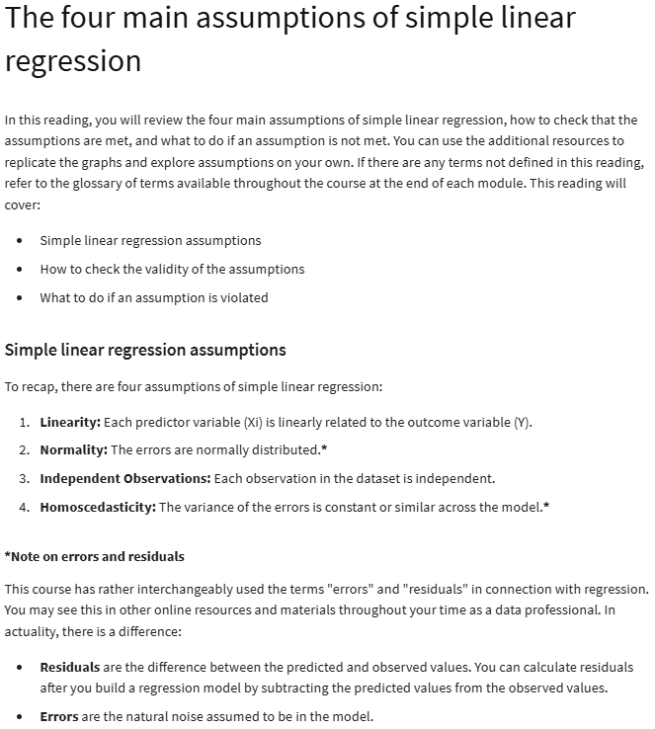

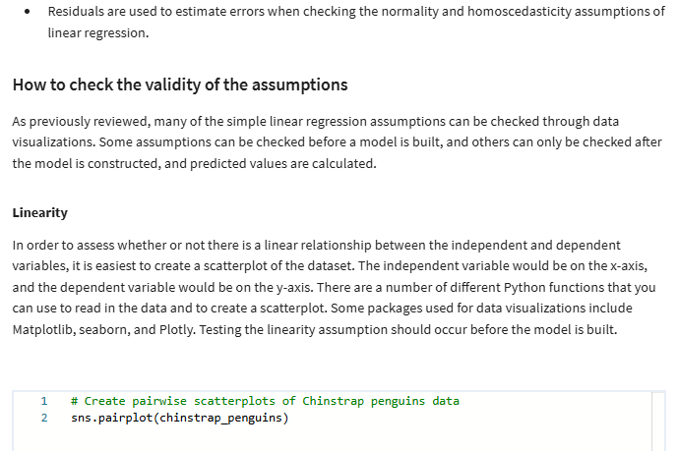

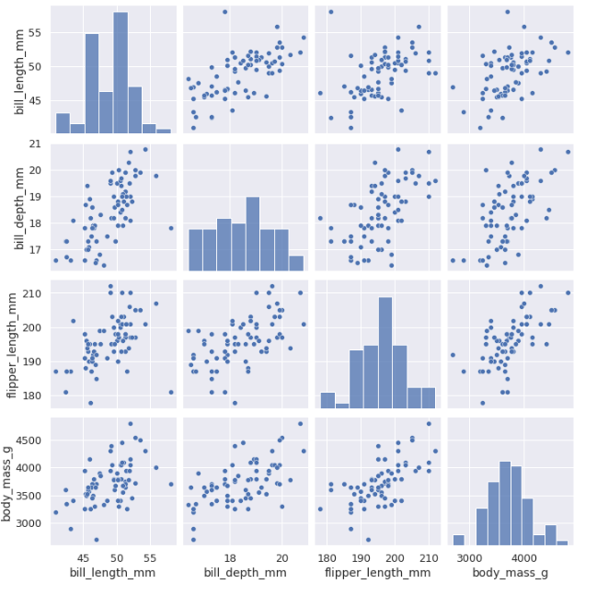

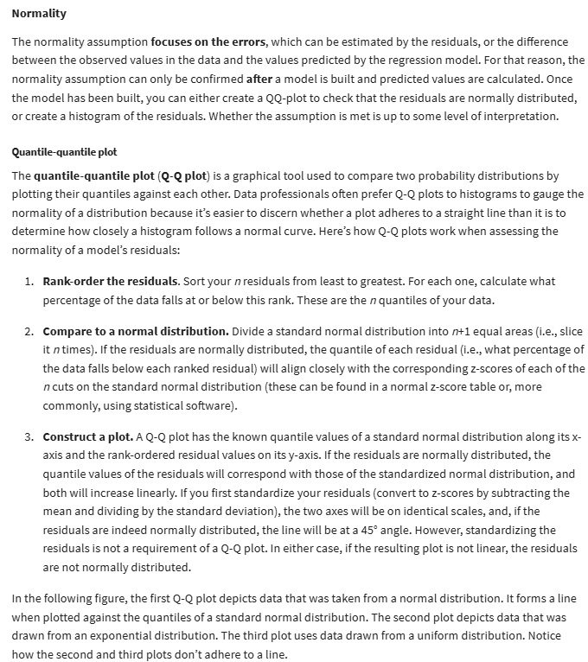

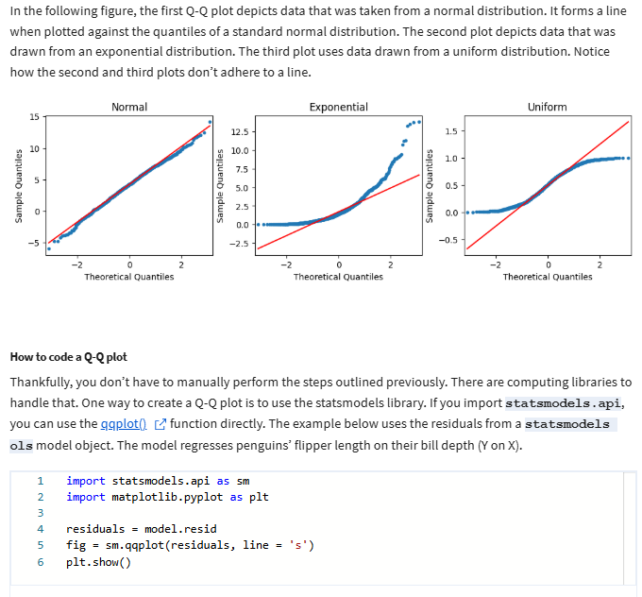

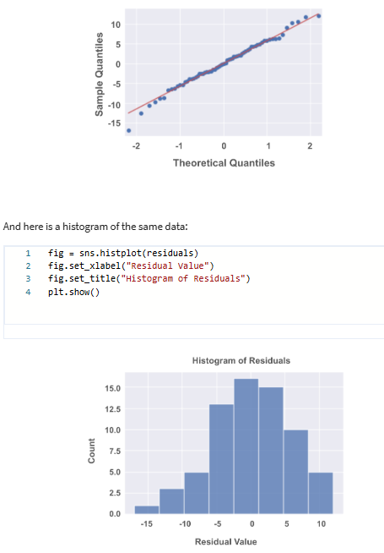

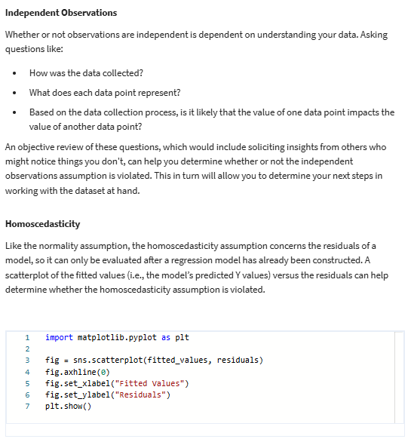

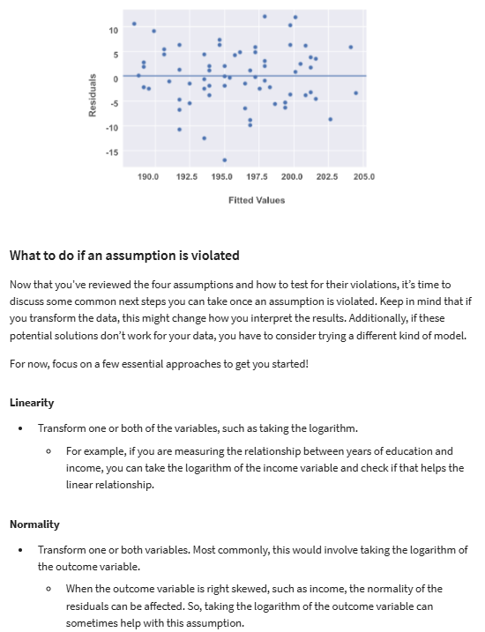

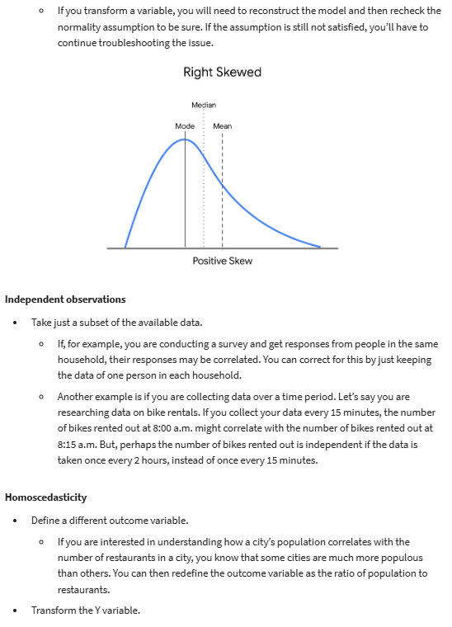



**Explore linear regression with Python**

* Scatterplot matrix: a series of scatterplots that show the relationship between pairs of variables

**Evaluate uncertainty in regression analysis**

* Confidence band: the area surrounding the line that describes the uncertainty around the predicted outcome at every value of X

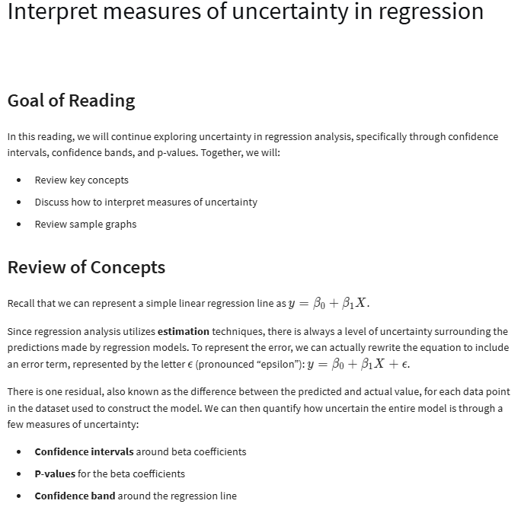

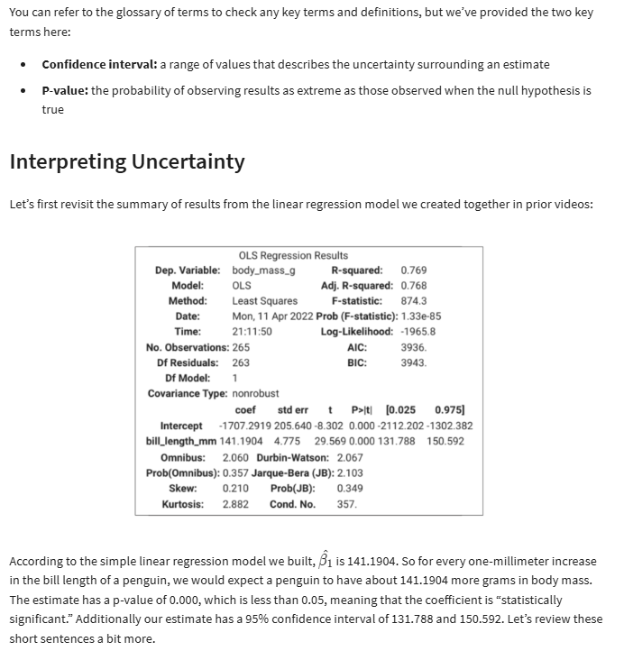

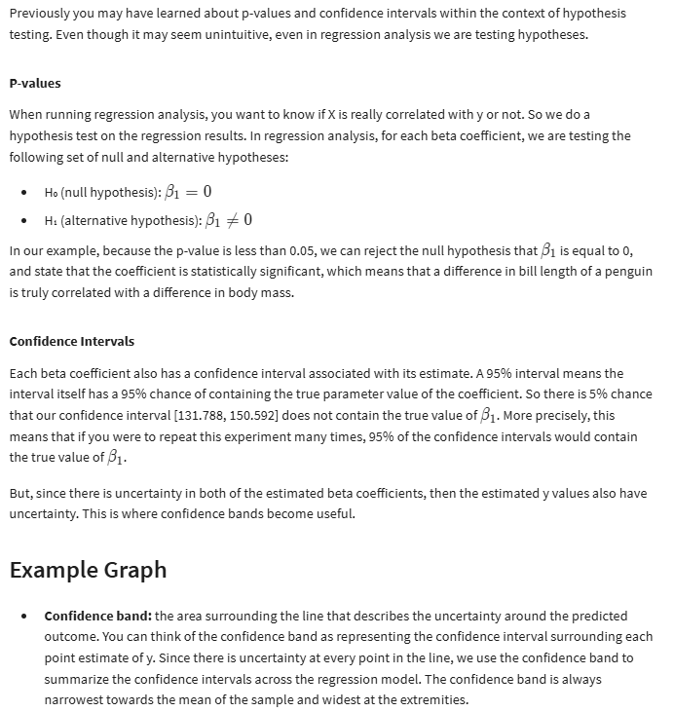

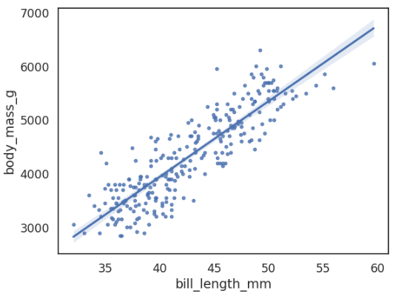

**Model evaluation metrics**

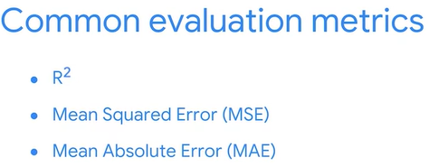

* R2 (coefficient of determination): measures the proportion of variation in the dependent variable, Y, explained by the independent variable(s), X
* Hold-out sample: a random sample of observed data that is not used to fit the model.

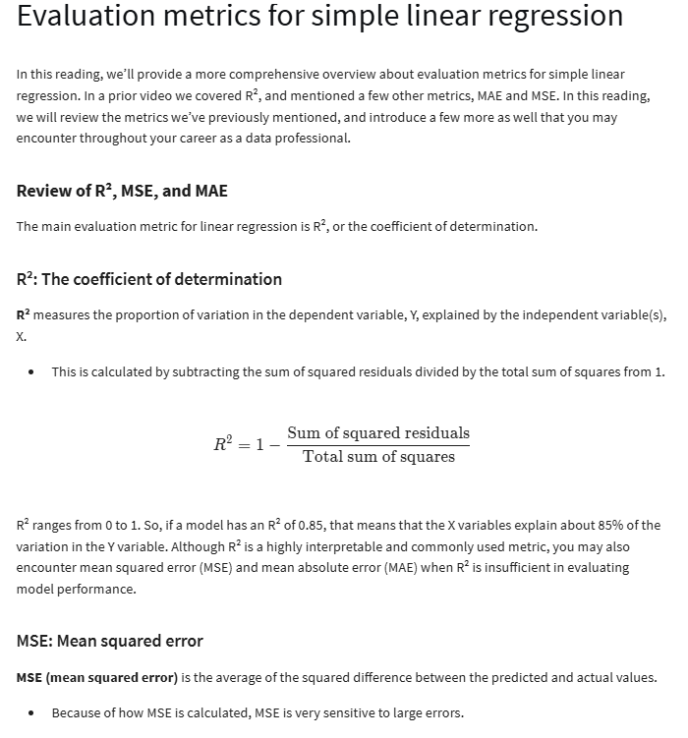

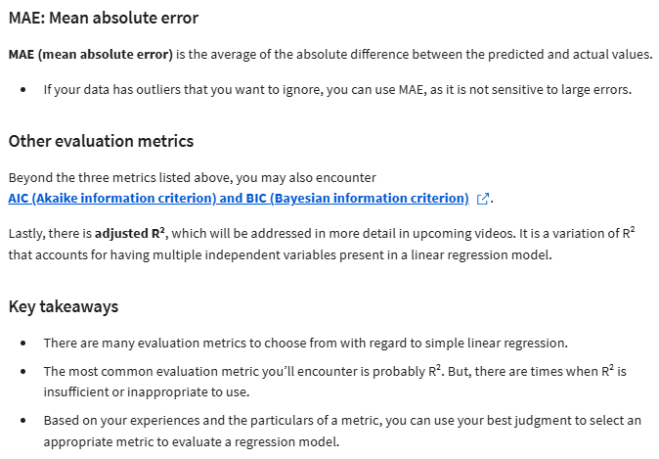

**Interpret and present linear regression results**

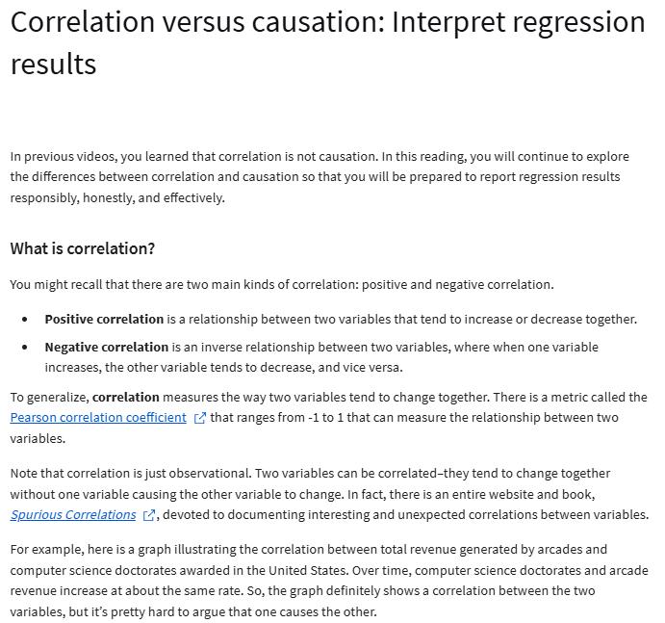

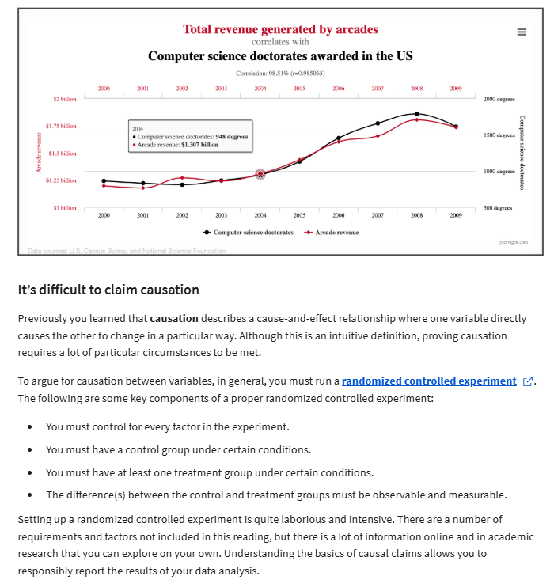

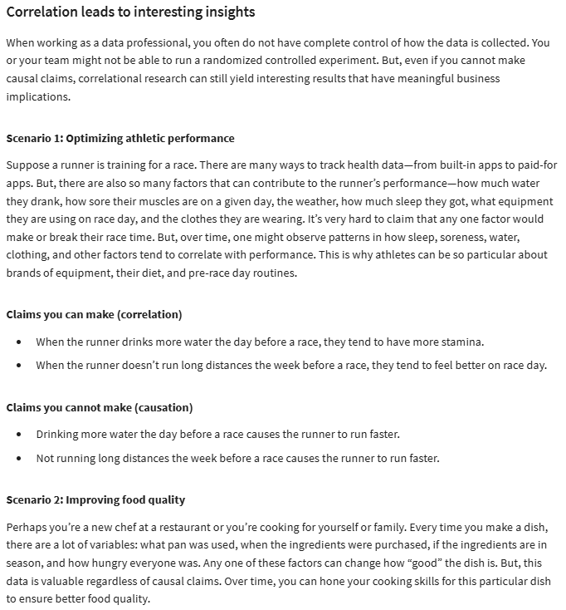

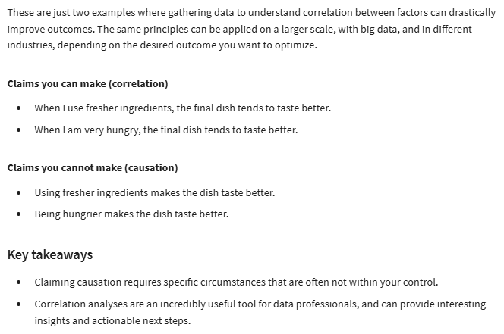

**WEEK 3:**

* Multiple linear regression or multiple regression: a technique that estimates the relationship between one continuous dependent variable and 2 or more independent variables.

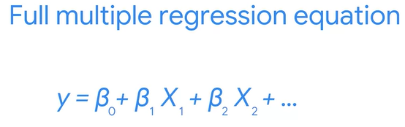

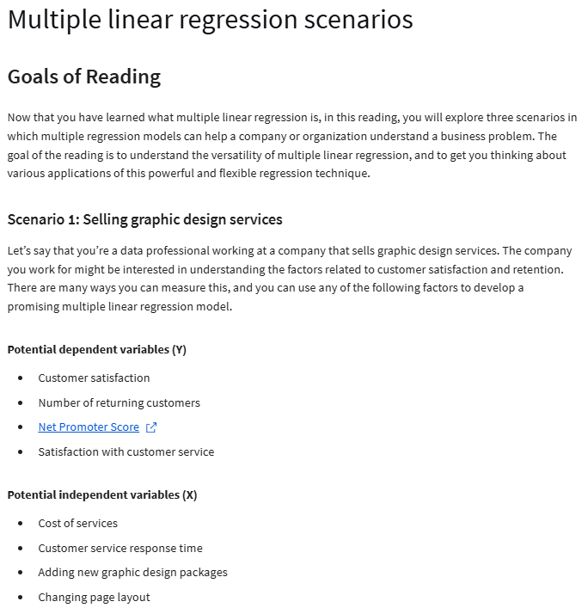

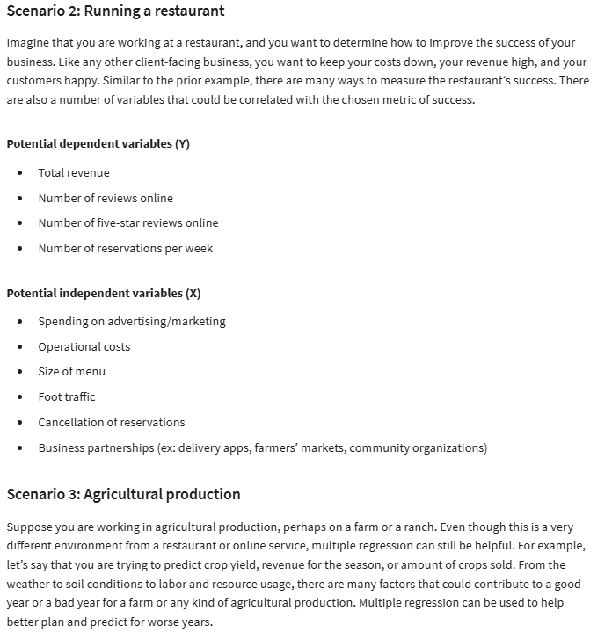

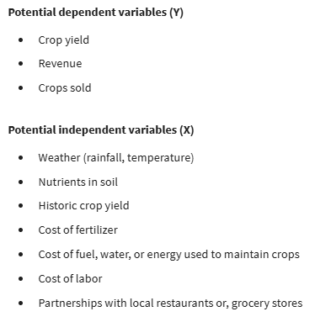

**Represent categorical variables**

* One hot encoding: a data transformation technique that turns one categorical variable into several binary variables.



**Make assumptions with multiple linear regressions**

* Independent observation assumption: each observation in the dataset is independent
* Normality assumption: the residuals are normally distributed
* Homoscedasticity assumption: the variation of residuals (errors) is constant or similar across the model
* No multicollinearity assumption: no 2 independent variables (Xi and Xj) can be highly correlated with each other
* Variance inflation factors (VIF): quantifies how correlated each independent variable is with all of the other independent variables
* How to handle data with multicollinearity
* Drop one or more variables that have high multicollinearity
* Create new variables using existing data

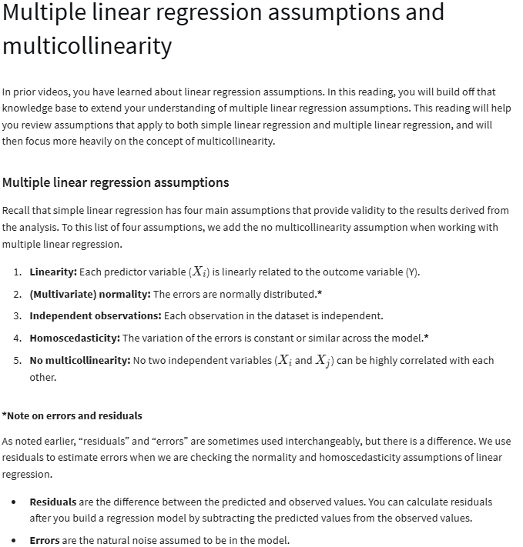

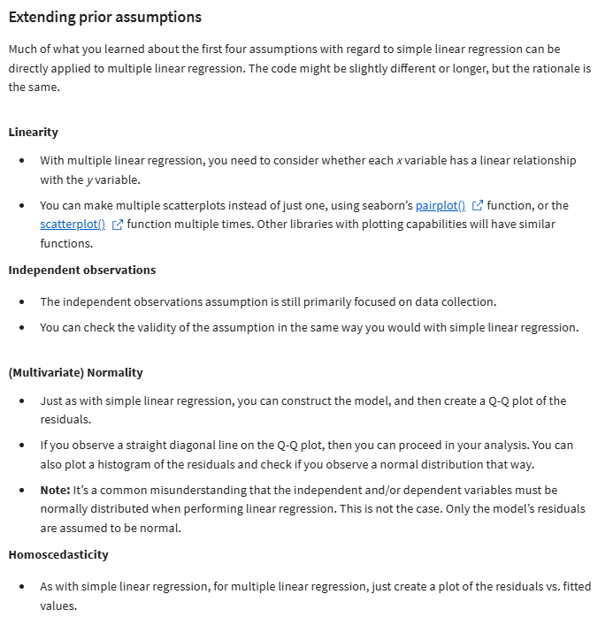

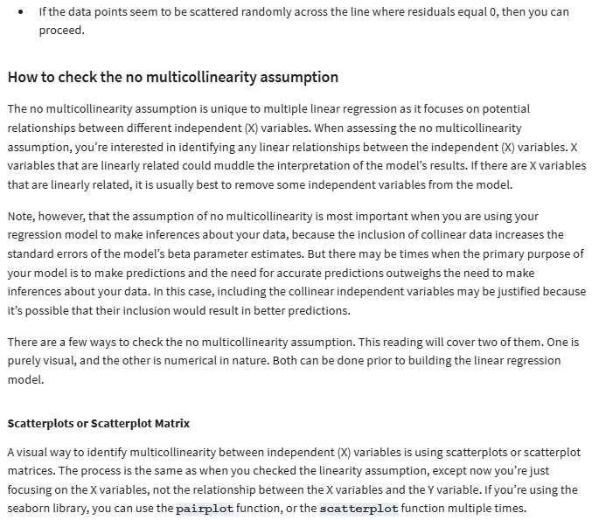

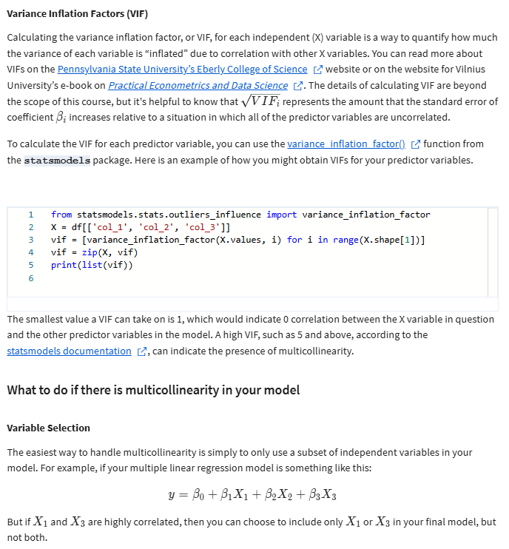

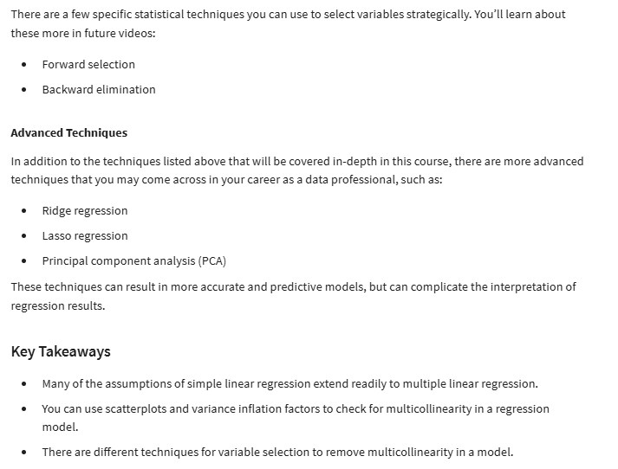

**Interpret multiple regression coefficients**

* Interaction term: a term that represents how the relationship between 2 independent variables is associated with changes in the mean of the dependent variable

**The problem with overfitting**

* Overfitting: when a model fits the observed or training data too specifically, and is unable to generate suitable estimates for the general population.
* Adjusted R2: a variation of the R2 regression evaluation metric that penalizes unnecessary explanatory variables.

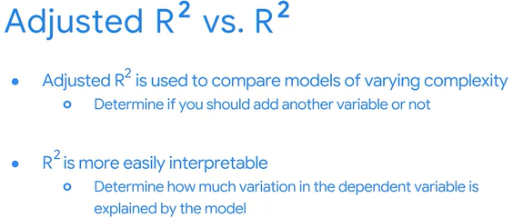

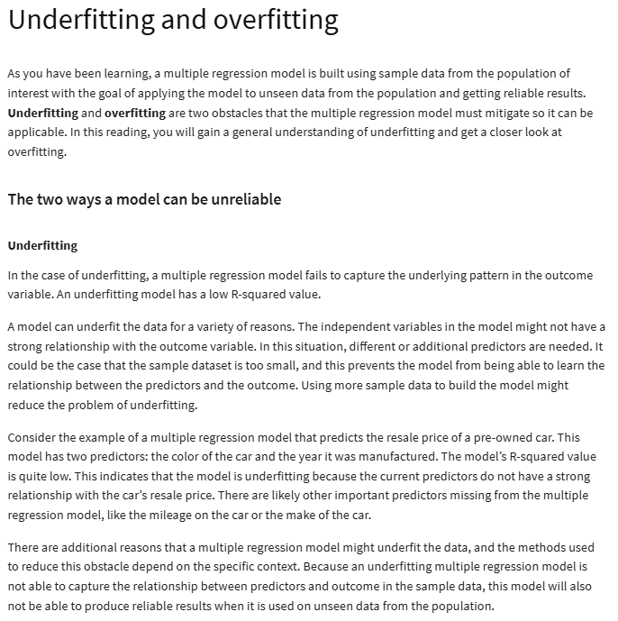

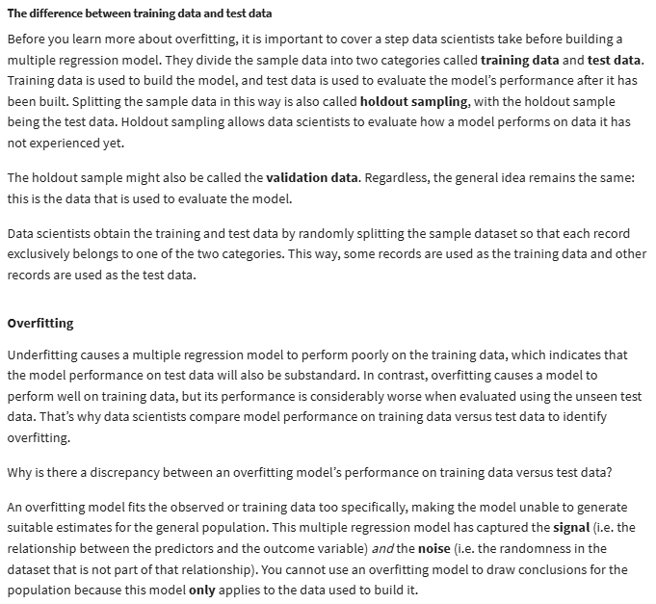

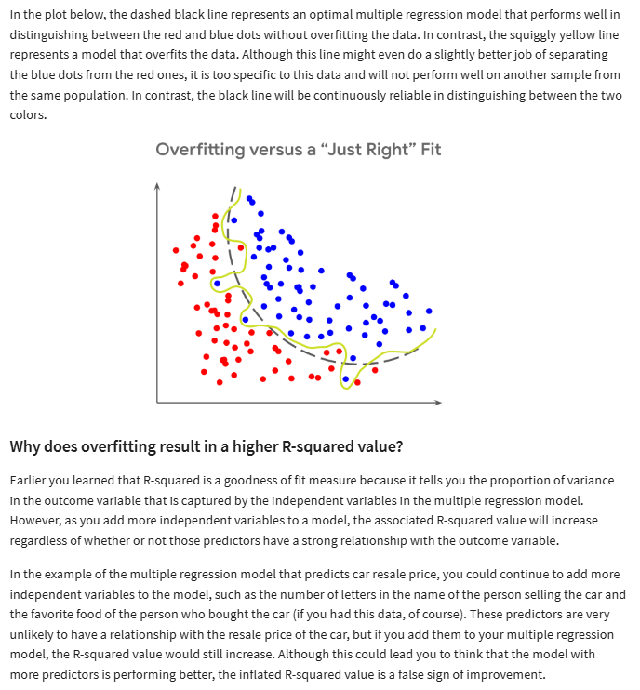

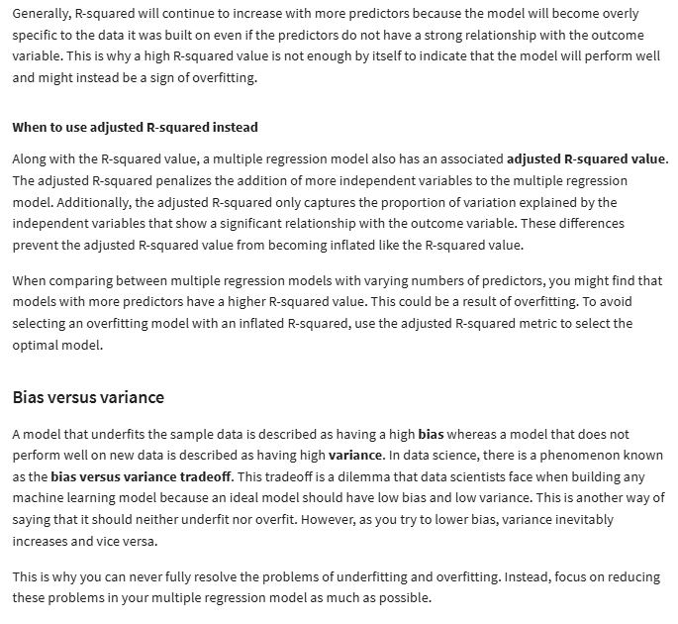

**Top variable selection methods**

* Variable selection or feature selection: the process of determining which variables or features to include in a given model
* Forward selection: a stepwise variable selection process that begins with the NULL model, with 0 independent variables, considers all possible variables to add. It incorporates the independent variable that contributes the most explanatory power to the model.
* Backward elimination: a stepwise variable selection process that begins with the full model, with all possible independent variables, and removes the independent variable that adds the least explanatory power to the model
* Extra-sum-of-squares F-test: quantifies the difference between the among of variance that is left unexplained by a reduced model that is explained by the full model.

Regularization: Lasso, Ridge, and Elastic Net regression

* Bias-variance tradeoff: balance between 2 model qualities, bias and variance, to minimize overall error for unobserved data.
* Bias: simplifies the model predictions by making assumptions about the variable relationships. A highly biased model may oversimplify the relationship, underfitting to the observed data, and generating inaccurate estimates.
* Variance: model flexibility and complexity, so the model learns from existing data. A model with high variance can overfit to observed data and generate inaccurate estimates for unseen data.

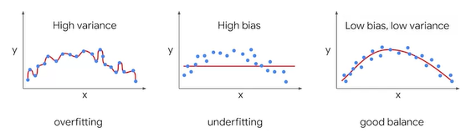

* Regularization: a set of regression techniques that shrinks regression coefficient estimates toward zero, adding in bias, to reduce variance
* Lasso regression
* Ridge regression
* Elastic-net regression

**WEEK 4:**

* Hypothesis testing: a statistical procedure that uses sample data to evaluate an assumption about a population parameter

**Hypothesis testing with chi-squared**

* Chi-squared goodness of fit test: determines whether an observed categorial variable follows an expected distribution
* Null hypothesis:
* 25 people buy each size of popcorn on any given day
* The variable follows the expected distribution
* Alternative hypothesis:
* The variable does NOT follow the expected distribution
* Different numbers of people buy each size of popcorn on any given day
* Chi-squared test for independence: determines whether or not 2 categorial variables are associated with each other
* Null hypothesis:
* The variables are independent, and not associated with each other
* Alternative hypothesis:
* The variables are NOT independent, and are associated with each other

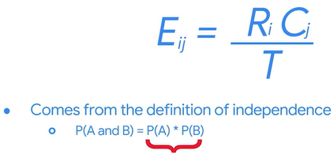

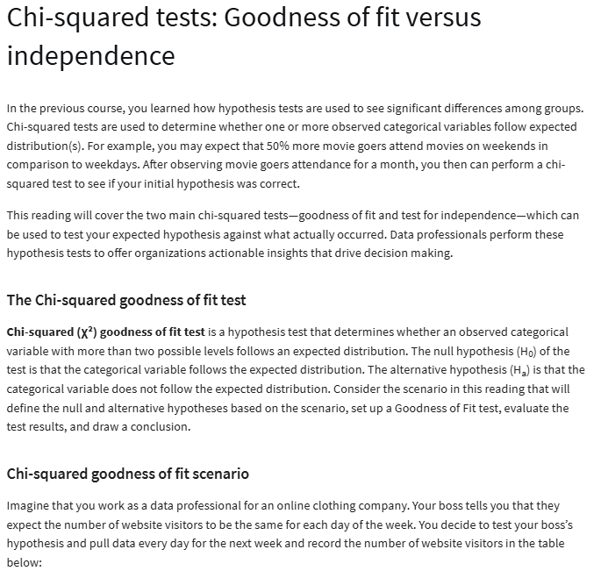

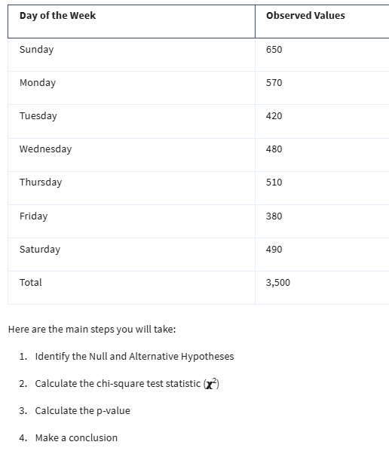

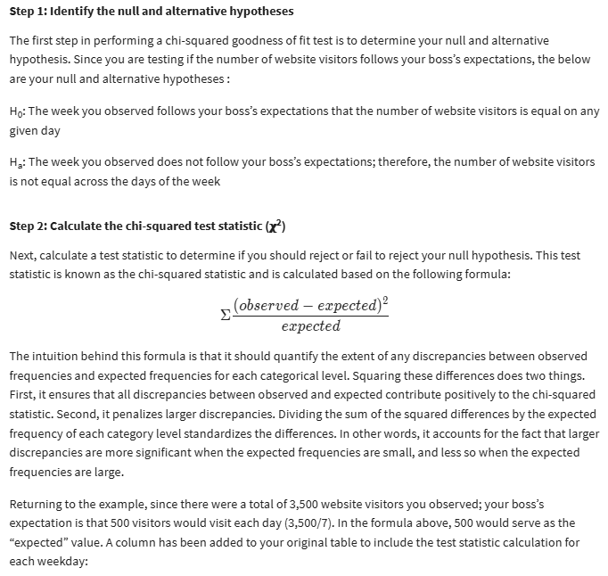

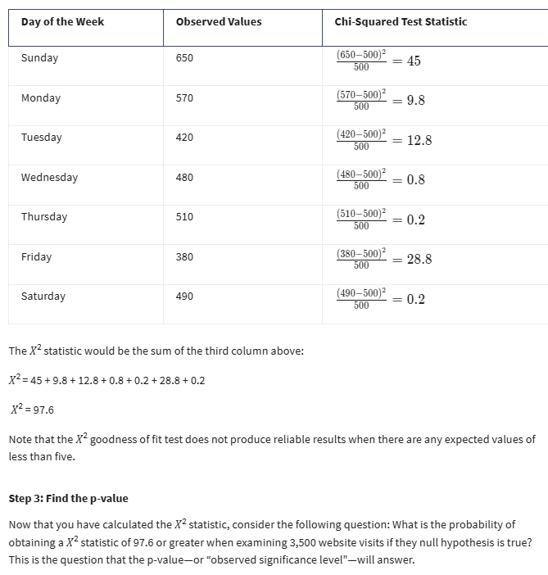

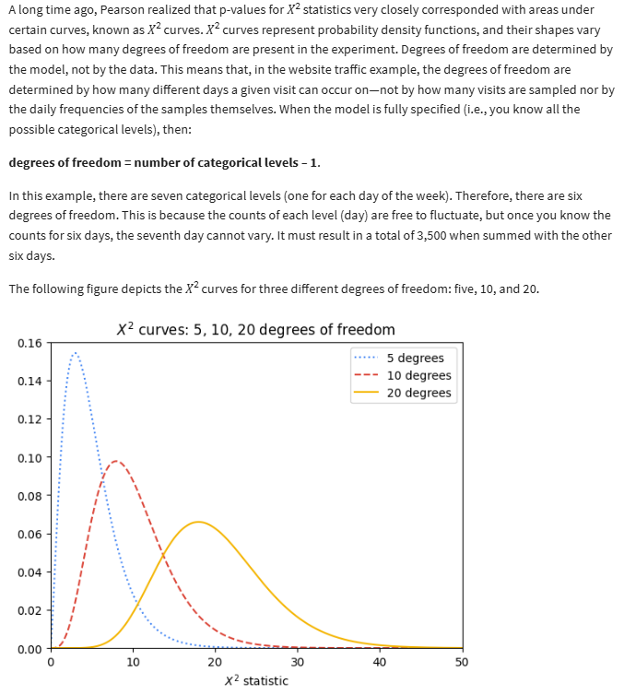

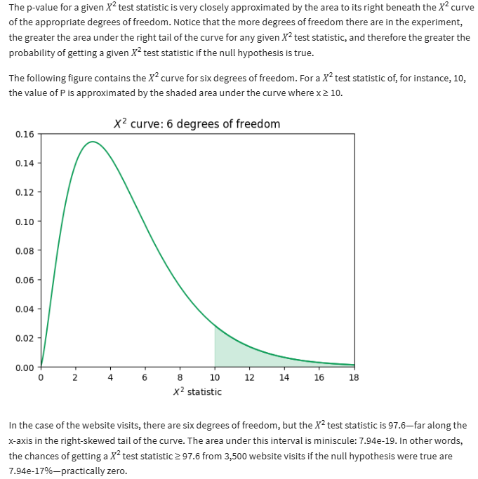

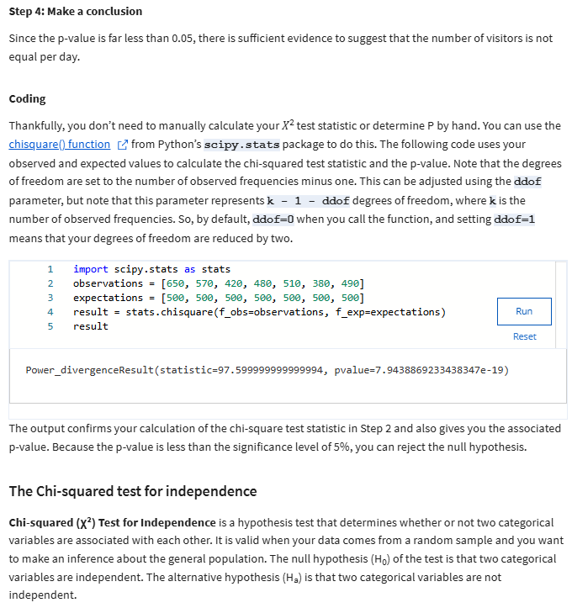

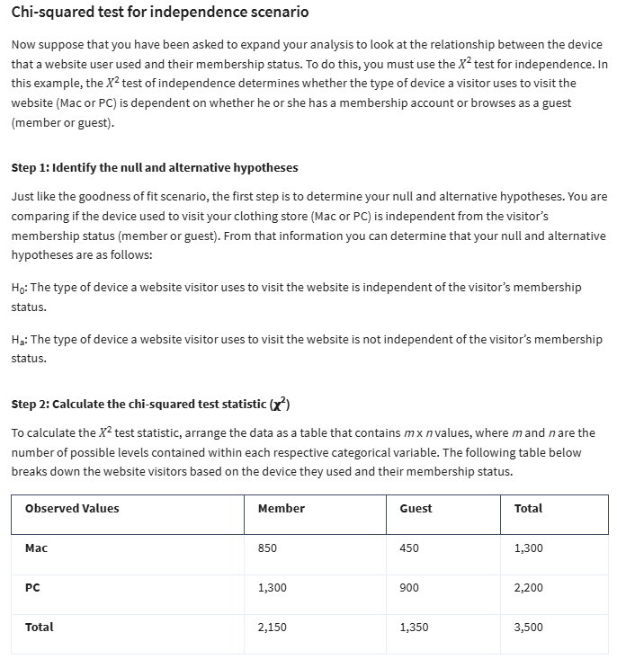

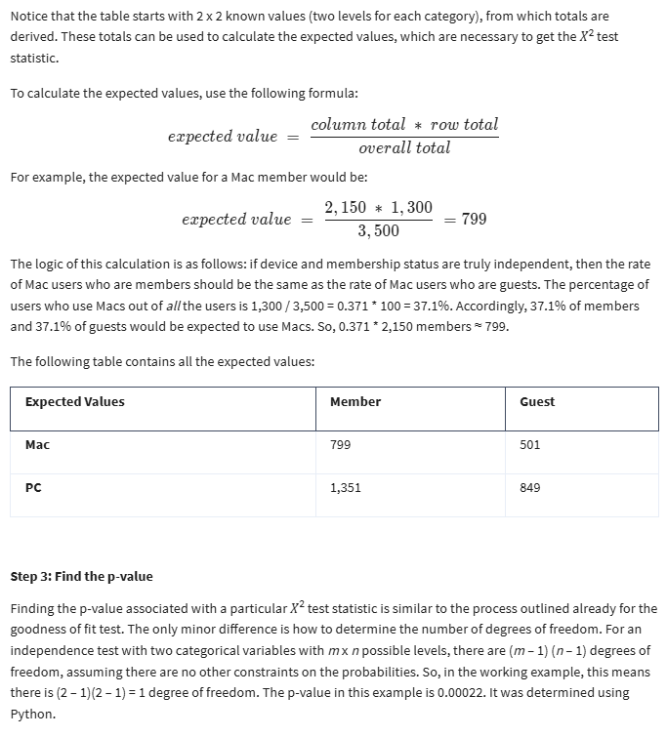

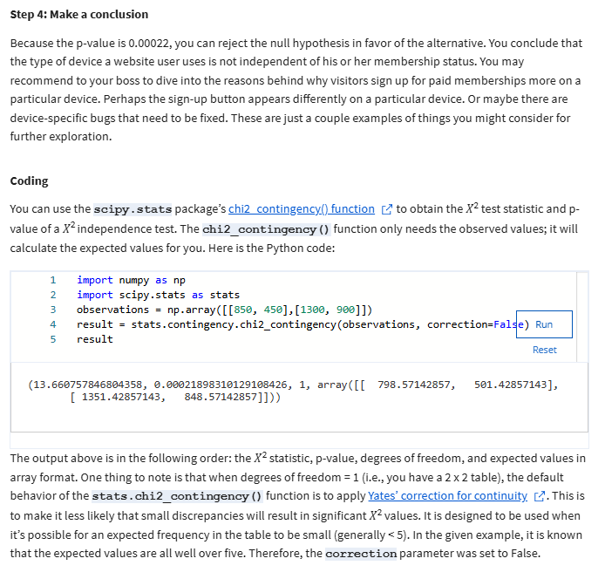

**Introduction to the analysis of variance (ANOVA)**

* Analysis of variance (ANOVA): a group of statistical techniques that test the difference of means between 3 or more groups
* One-way ANOVA: compares the means of 1 continuous dependent variable based on 3 or more groups of 1 categorical variable.

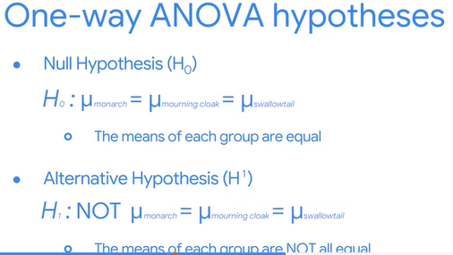

* Two-way ANOVA: compares the means of 1 continuous dependent variable based on 3 or more groups of 2 categorical variables

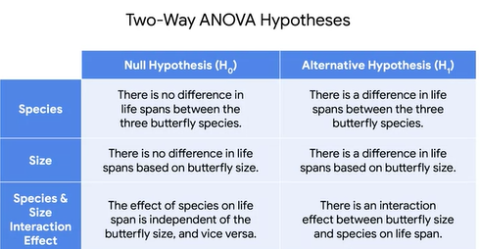

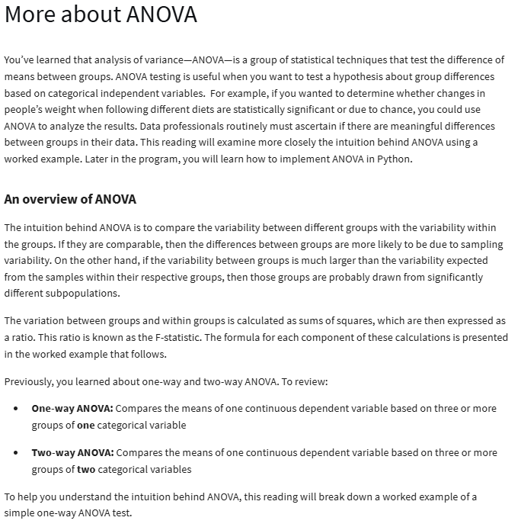

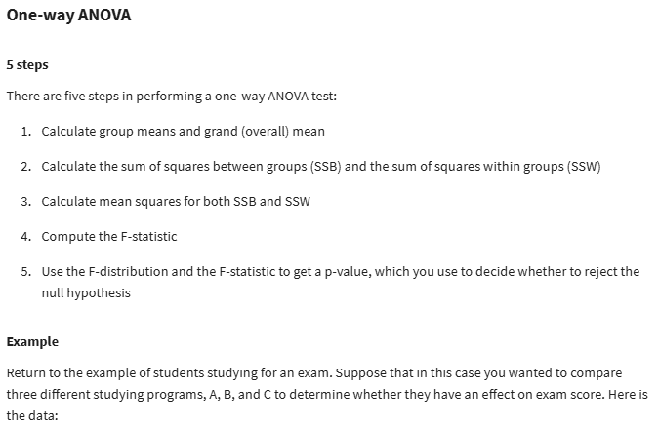

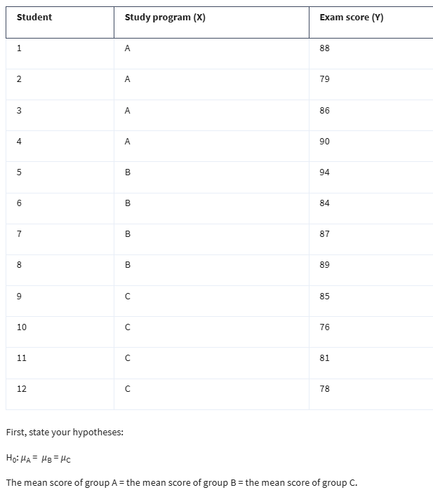

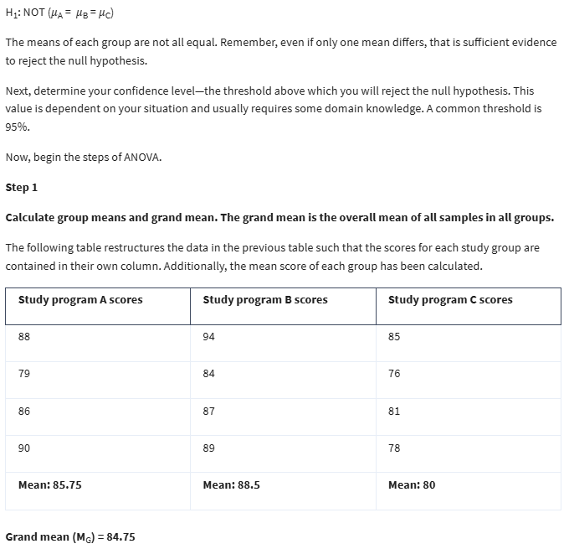

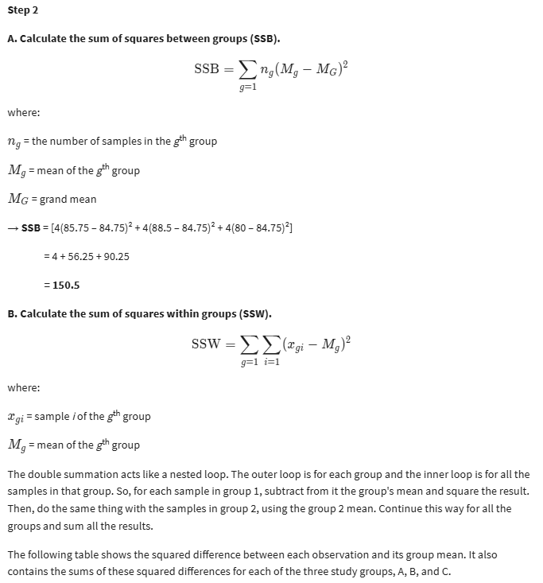

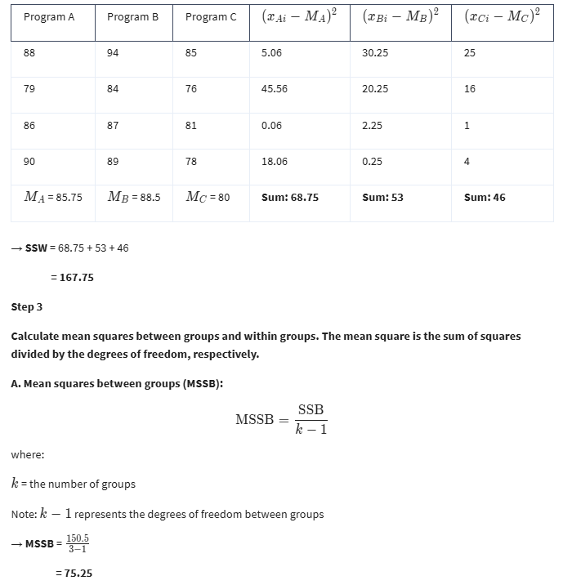

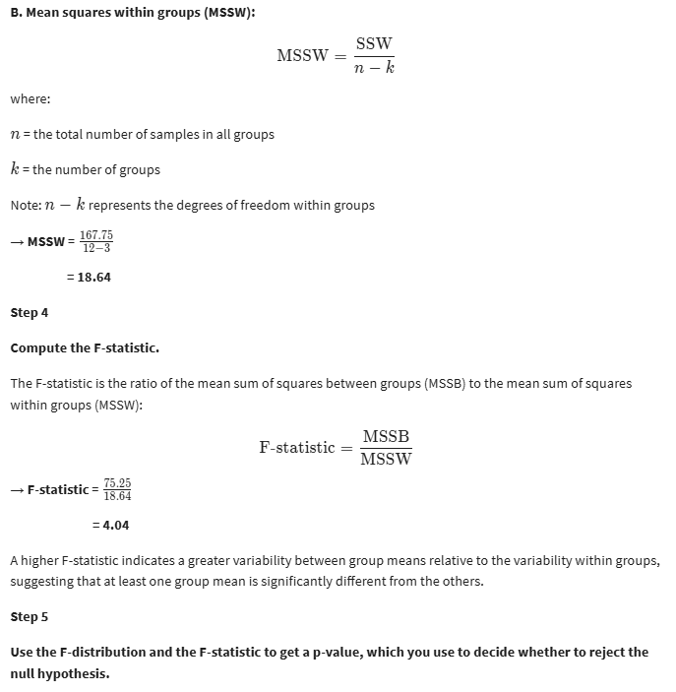

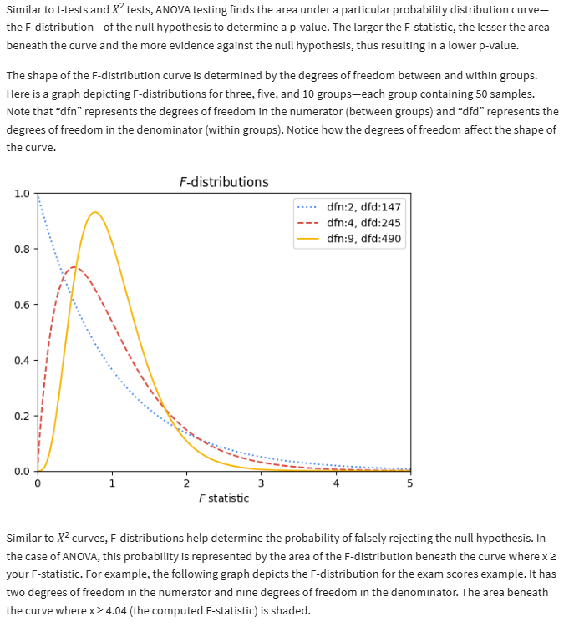

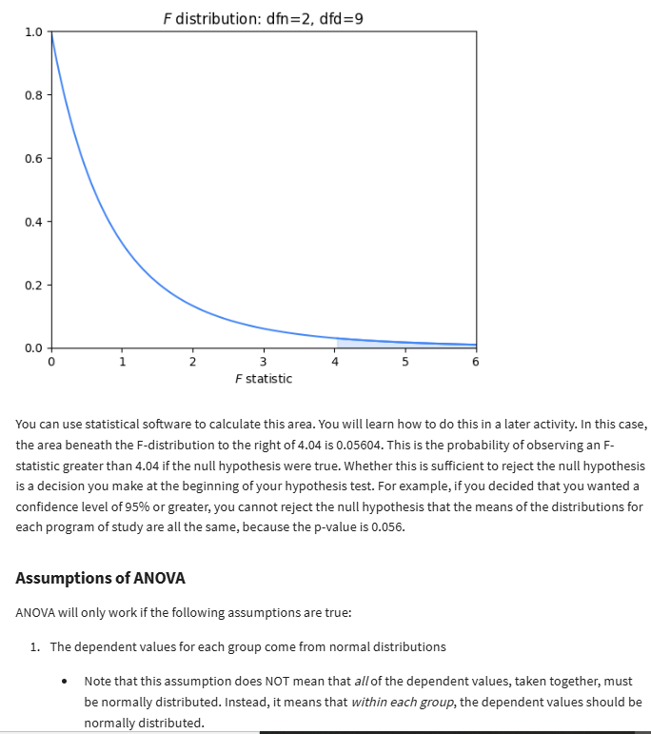

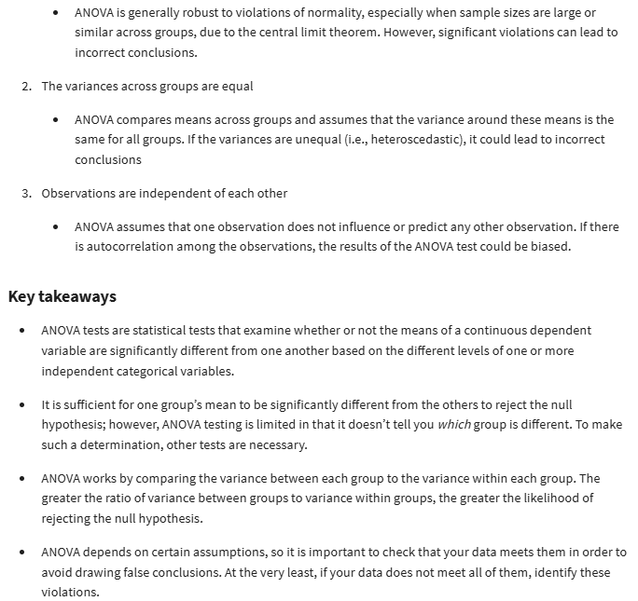

Explore one-way vs. two-way ANOVA tests with Python

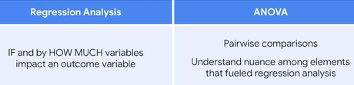

**ANOVA post hoc tests with Python**

* Post hoc test: performs a pairwise comparison between all available groups while controlling for the error rate

**ANCOVA: Analysis of covariance**

* ANCOVA: a statistical technique that tests the difference of means between 3 or more groups while controlling for the effects of covariates, or variables irrelevant to your test

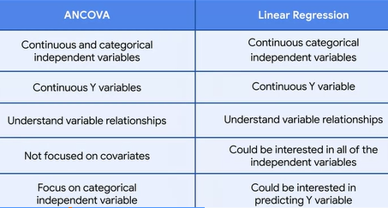

More dependent variables: MANOVA and MANCOVA

* MANOVA (multivariate analysis of variance): an extension of ANOVA that compares how 2 or more continuous outcome variables vary according to categorical independent variables
* One-way MANOVA: one categorical independent variable
* Two-way MANOVA: 2 categorical independent variables
* Continuous outcome variables:
* MANCOVA (multivariate analysis of covariance): an extension of ANCOVA and MANOVA that compares how 2 or more continuous outcome variables vary according to categorical independent variables while controlling for covariates.

**WEEK 5:**

* Logistic regression: a technique that models a categorical dependent variable (Y) based on one or more independent variables (X)
* Binomial logistic regression: a technique that models the probability of an observation falling into one of two categories, based on one or more independent variables.
* Linearity
* independent observation
* no multicollinearity
* no extreme outliers

**Find the best logistic regression model for your data**

* Binomial logistic regression linearity assumptions: there should be a linear relationship between each X variable and the logit of the probability that Y equals 1
* Logit (log-odds): the logarithm of the odds of a given probability. So the logit of probability p is equal to the logarithm of p divided by 1 minus p

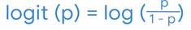

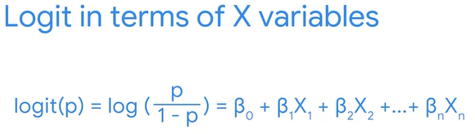

* Maximum likelihood estimation (MLE): a technique for estimating the beta parameters that maximize the likelihood of the model producing the observed data
* Likelihood: the probability of observing the actual data, given some set of beta parameters.
* The best logistic regression model estimates the set of beta coefficients that maximizes the likelihood of observing all of the sample data.

**Evaluate a binomial logistic regression model**

* Confusion matrix: a graphical representation of how accurate a classifier is at predicting the labels for a categorical variable

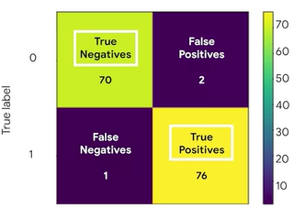

**Key metrics to assess logistic regression results**

* Precision
* Recall
* Accuracy
* Precision: the proportion of positive predictions that were true positives



* Recall: the proportion of positives the model was able to identify correctly



* Accuracy: the proportion of data points that were correctly categorized



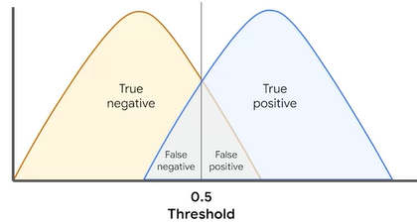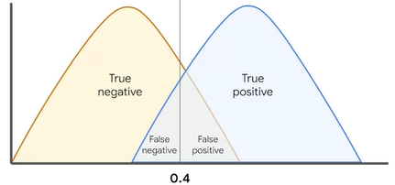

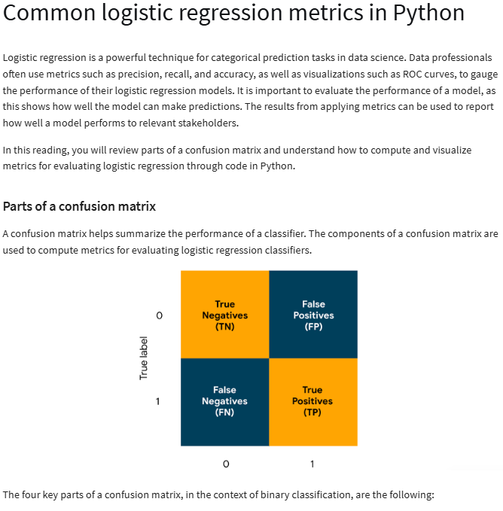

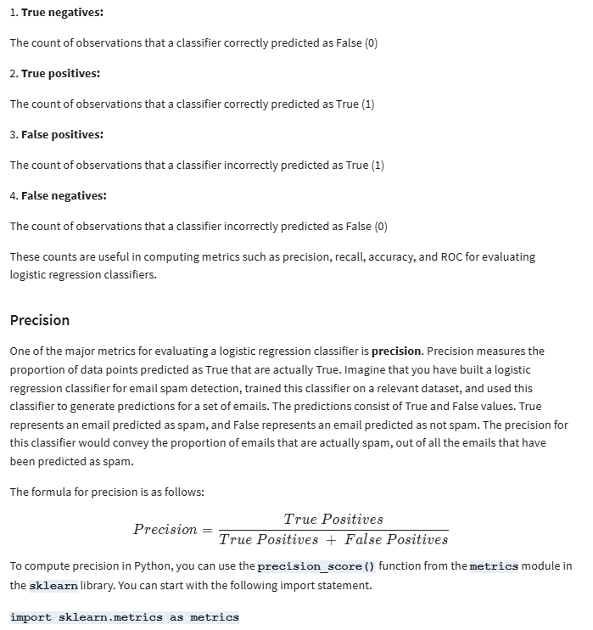

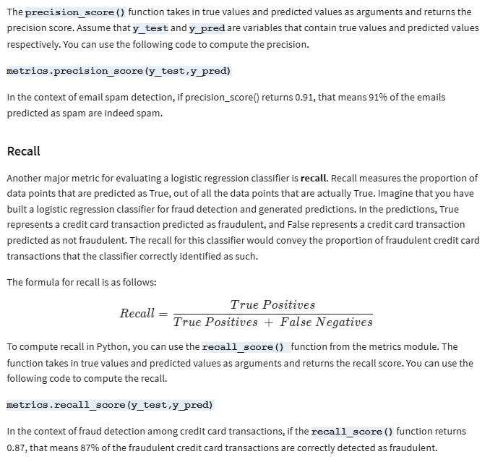

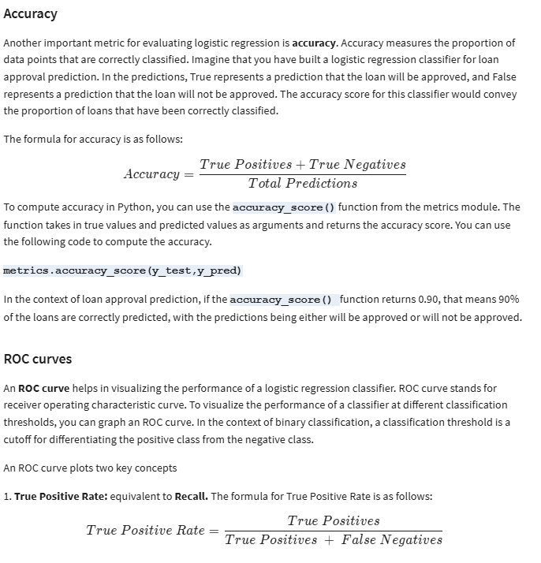

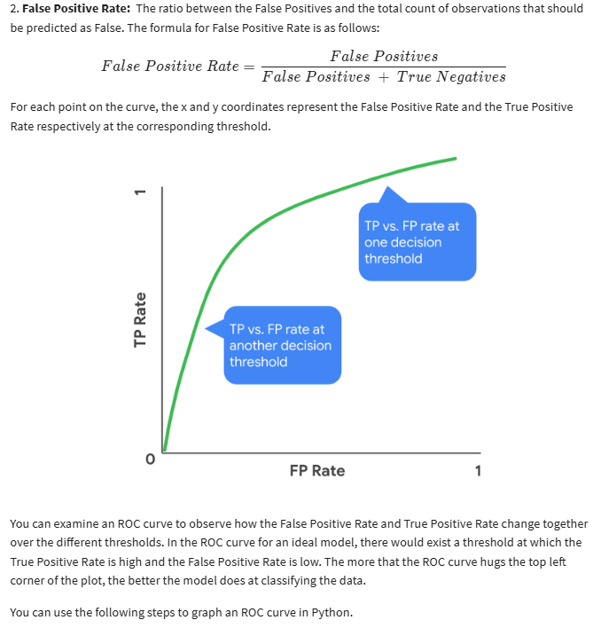

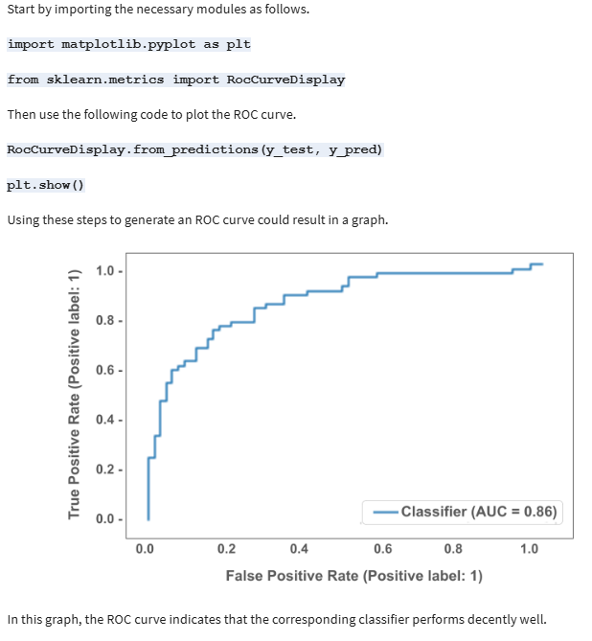

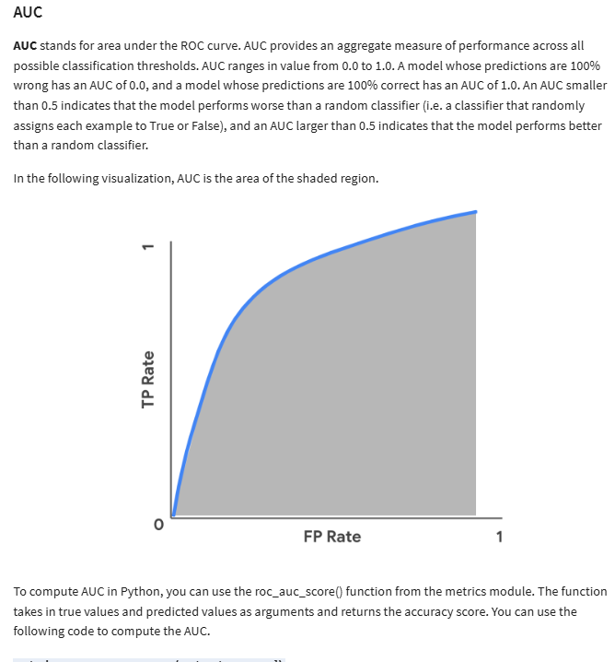

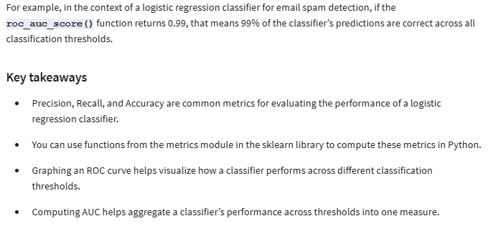

**Interpret the results of a logistic regression**



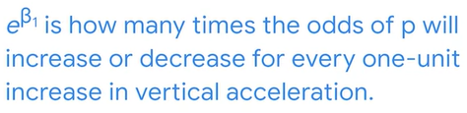

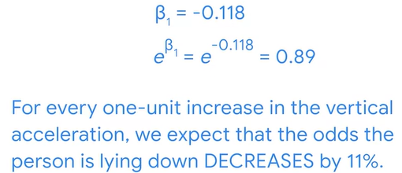

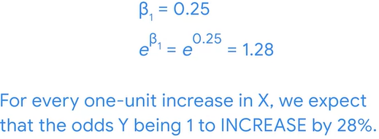



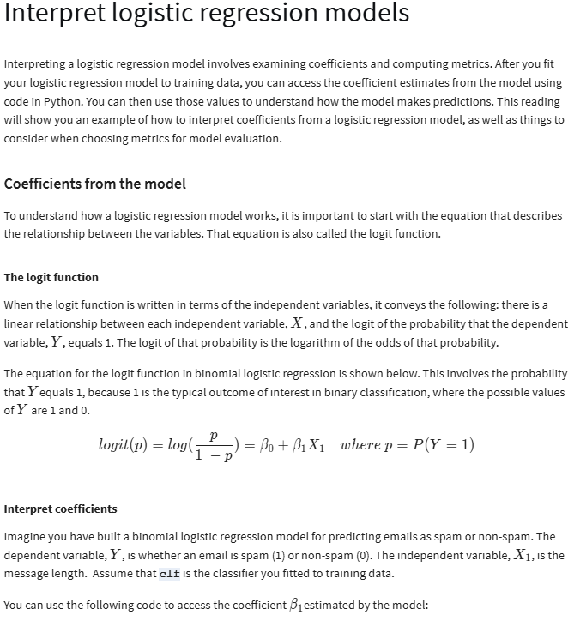

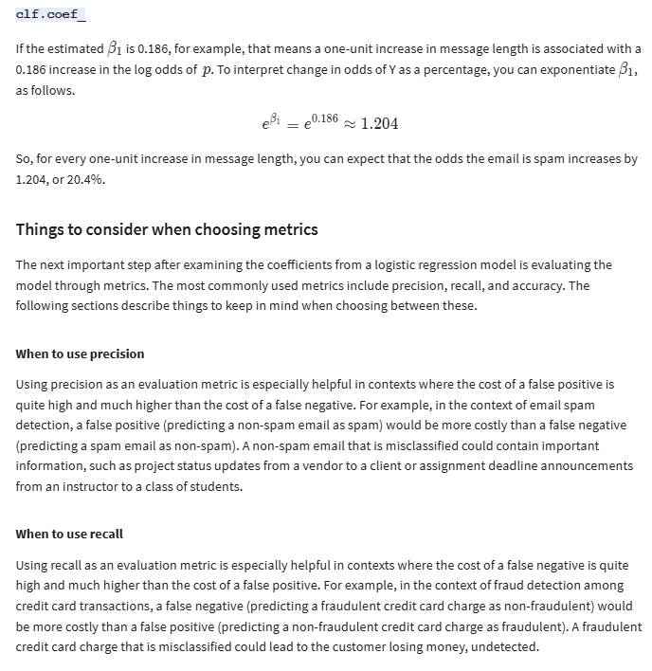

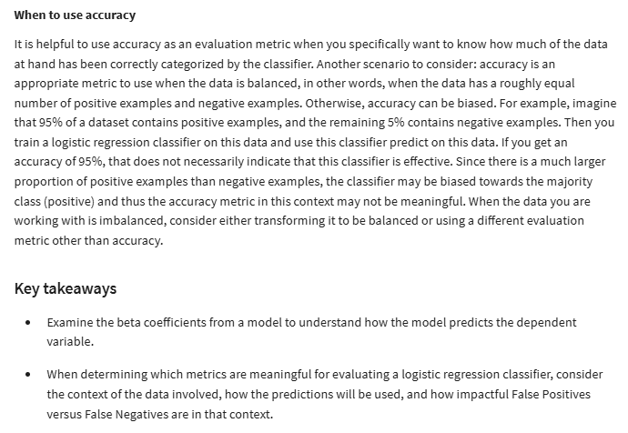

**Answer questions with regression models**

* Linear regression:
* Accessible interpretation
* Explain which factors impact the outcome variables
* Check model assumptions

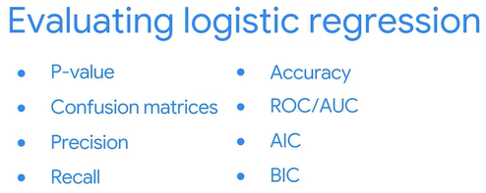

* Logistic regression coefficients report in percentages how much a factor increases or decreases **the likelihood of an outcome.**

